Delete Employee Testcase-UI

**Environment:** QA Test Challenge

**Platforms:** Desktop Browsers, Mobile Browsers and Native App.

**Preconditions:** User has the ability to add Employees in the Benefits Dashboard. Existing Employees to update.

**Products:** Benefits Administration Dashboard

**User Access:** Add, Edit and Delete an Employee

**Testing Challenge Testcases.**

**Scenario Delete Employee:**

**1A. Delete Employee Happy Path**

**Steps to test:**

1. Log in to Paylocity
2. Click the Delete Employee button
3. Add the Employees first, last name and number of dependents
4. Click the Delete button
5. Verify expected results

**Expected results:**

* 1. The Employee will be removed from the Benefits Dashboard

**1B. Delete Employee Cancel and Close**

**Steps to Test:**

1. Log in to Paylocity
2. Click the Delete Employee button
3. Click the Cancel Button
4. Click the Delete Employee button
5. Click the close button

**Expected results:**

1. When the user clicks Cancel the employee will not be deleted.
2. When the user clicks the Close button, the employee will not be deleted.

**Exploratory Testing:**

1. Validate the form is correct, the table fields as well as the windows that open.
2. Test navigating between views and see how it affects usability.
3. Let the session timeout and see how the application handles it.
4. Refresh the session and see how the application handles it.
5. Resize the window and see how the application handles the resize.
6. Make your browser lose connectivity and see how the application handles it.

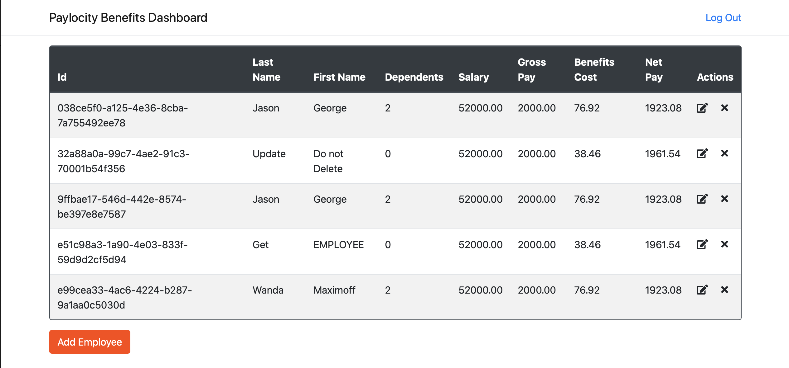

Dashboard screen

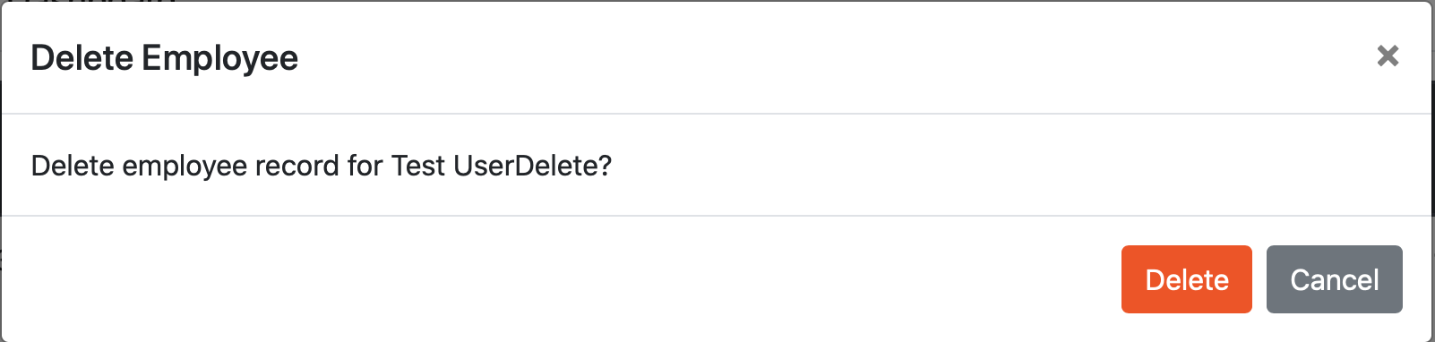

Delete Employee screen